# **Learning Session 3: Reflective Supervision: A Key to Workforce Well-being and Resilience**

Participant Reflection Worksheet

Session 3 Review

It's important to understand how both reflective practice and reflective supervision approaches support personal growth, professional development, and deeper connection within the home visiting workforce.

|  |  |
| --- | --- |
| **Reflective Practice** | **Reflective Supervision** |
| * An internal process in which professionals step back from their direct work with families to consciously examine their own emotions, experiences, actions and responses. | * Structured, relationship-based process that supports professional in engaging in reflective practice, typically facilitated by a supervisor or consultant. |

Reflective Supervision Conceptual Model

Dr. West shared information about the *Strengthening and Supporting the Home Visiting Workforce* project, focusing on reflective supervision. Her team developed a conceptual model for reflective supervision in home visiting, a planning tool for supervisors, and measure of reflective supervision in home visiting. The conceptual model outlines key supervision elements and contextual factors affecting its effectiveness. Over 500 supervisors representing a diversity of demographic characteristics, evidence-based models used, and agency type participated in developing and testing the draft measure. The next phase of the project will include finalizing the measure and a guide for using it.

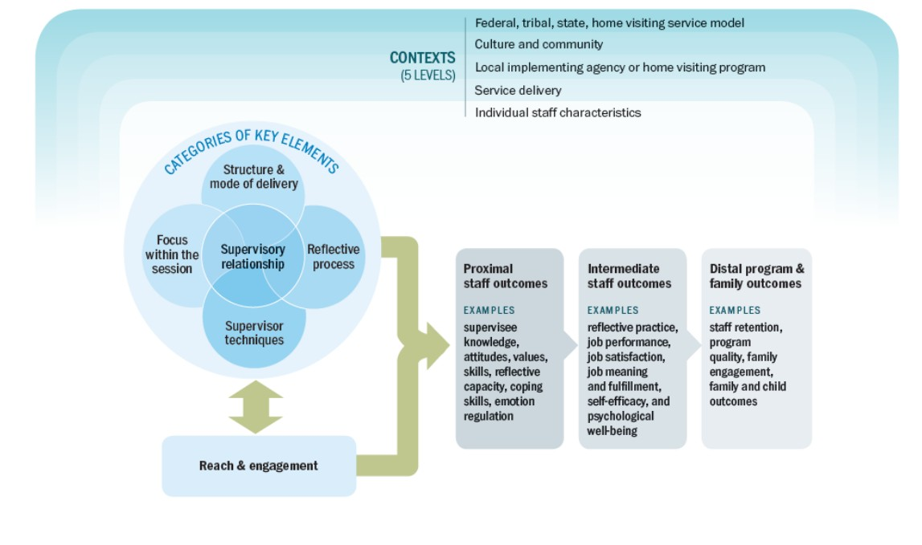

Reflection

|  |
| --- |
| *How does this conceptual model of reflective supervision in home visiting resonate with you and your experiences?* |
|  |

|  |
| --- |
| *Why does reflective supervision matter? How might Reflective Supervision promote home visitor professional well-being and Joy in Work?* |
|  |

|  |
| --- |
| *What do you need to know or understand better to feel confident about participating or providing reflective supervision in your agency?* |
|  |

Integration

|  |
| --- |
| *What does your organization currently do to support reflective practice/reflective supervision in your home visiting program(s) (e.g. training for staff, individual or group reflective supervision for supervisors and program leadership, etc.)?* |
|  |

|  |
| --- |
| *What would you like to see your organization do to support reflective practice/reflective supervision in your home visiting program(s)?* |
|  |

|  |
| --- |
| *How does the practice of reflective supervision in your program look similar to or different from the way it has been described by your peers on the panel?* |
|  |

Action

|  |
| --- |
| *Which areas of reflective supervision would you like to focus more on (e.g. identify resources and training/professional development opportunities for both home visitors and supervisors, ensure reasonable supervisor caseloads, provide supports for supervisors to receive reflective supervision)? Where would you like to start? How could TA support you to take action?* |
|  |

|  |
| --- |
| *How might you/your program use the SAS-HV supervisor planning tool to support both supervisors and home visitors to improve their reflective practice?* |
|  |

|  |
| --- |
| *Write down 1-2 action steps you can take to start or enhance reflective supervision in your program(s). Consider what types of support you might need from your colleagues, supervisor or leadership to engage in these activities. You can also consider using the “Workforce Institute PDSA Template” to develop and run a PDSA cycle based on your action idea!* |
|  |

Resources:

* Region X Reflective Supervision Collaborative. (2018). *Reflective Supervision: A Guide from Region X to Enhance Reflective Practice Among Home Visiting Programs*. Region X Innovation Grant, Maternal, Infant, and Early Childhood Home Visiting Program, U.S. Department of Health and Human Services, Health Resources and Services Administration.
* Sparr, M., Johnson, H., & Quigley Clark, M. (2022). *Improving home visitor professional well-being: A resource for state and tribal home visiting programs, model representatives, and local programs* (OPRE Report No. 2022-139). Office of Planning, Research, and Evaluation; Administration for Children and Families; U.S. Department of Health and Human Services.
* University of New Mexico. (2022) [Podcast: Administrative Supervision vs. Reflective Supervision.](https://cdd.health.unm.edu/ecln/captivate-podcast/administrative-supervision-vs-reflective-supervision/)
* Wisconsin Alliance for Infant Mental Health (WI-AIMH). (2020). *Demystifying Reflective Practice: Defining Reflective Supervision and Consultation for Infant and Early Childhood Professionals*. Wisconsin Infant/Early Childhood Mental Health Policy Committee.
* West, A., & Madariaga, P. (2022). [*Reflective supervision: A planning tool for home visiting supervisors*](https://acf.gov/opre/report/reflective-supervision-planning-tool-home-visiting-supervisors) Office of Planning, Research, & Evaluation, Administration for Children and Families). U.S. Department of Health & Human Services. <https://wiaimh.org/reflective-supervision-and-consultation>